NEXORA
AI-Powered CRM & Business Management Platform
Product Overview Document
"Nexora is a modern AI-powered CRM platform that streamlines lead management, sales tracking, customer interactions, task management, and business operations through a centralized smart dashboard."
Team:
Team Member
Hrushikesh Harde
Diksha Rajpurohit
Vivek Arote
Sahil Mundada

1. Overview
Nexora is an AI-powered CRM and business management platform that helps organizations manage leads, meetings, calls, tasks, products, deals, tickets, and user management from a single unified dashboard.

Nexora replaces fragmented, manual processes with a cohesive digital ecosystem:

Challenges Replaced | Nexora Solutions
Manual lead tracking | Smart lead & deal management
Scattered customer data | Centralized CRM dashboard
Repetitive follow-ups | Streamlined interaction workflow
Unorganized task management | Organized task & meeting tracking
Inefficient deal monitoring | Real-time business analytics
Poor team coordination | Role-based user management
Lack of business insights | Improved team collaboration & productivity

2. Problem Statement
Businesses and organizations commonly face critical operational and customer management challenges:

- Scattered customer and lead data across multiple disconnected systems
- Inefficient follow-up processes leading to missed opportunities
- Poor task and deal tracking resulting in lost revenue
- Lack of centralized communication between teams
- Limited real-time business insights for informed decision-making
- Manual, error-prone workflow management
- Poor team coordination and reduced overall productivity

These challenges are prevalent across startups, sales teams, service-based companies, and growing enterprises — making a unified CRM solution essential.

3. Solution
Nexora addresses these pain points with a comprehensive, AI-enhanced platform built around five core pillars:

3.1 Smart CRM Management
A centralized platform to manage leads, deals, customers, products, and business operations efficiently — reducing data silos and improving response times.

3.2 Task & Meeting Management
Organize tasks, meetings, and follow-ups with structured tracking and automated workflow management to ensure nothing falls through the cracks.

3.3 Real-Time Analytics Dashboard
Live insights covering sales tracking, performance monitoring, and business analytics — empowering data-driven decisions at every level of the organization.

3.4 Role-Based User Management
Secure, granular access control for Admins, Managers, and Team Members with organized permissions that protect sensitive business data.

3.5 Ticket & Customer Support System
Manage customer issues, support tickets, and communications from a single platform — improving resolution times and customer satisfaction.

4. Target Users

Primary Users | Secondary Users
- Sales Teams  - Business Organizations  - Startups & Enterprises  - CRM Managers  - Customer Support Teams  - Business Development Executives  - Project & Operations Teams | - Service-Based Companies  - Marketing Teams  - HR & Management Teams  - Agencies & Consulting Firms  - Small & Medium Businesses  - Organizations managing customer relationships

5. Product Workflow
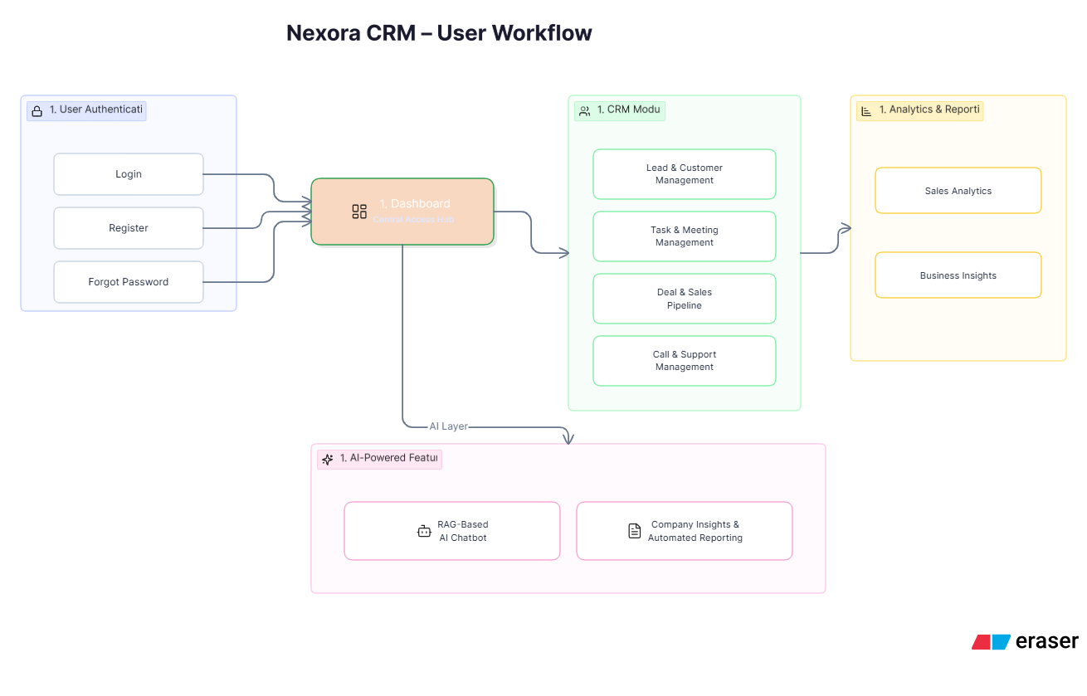

6. Core Features

CRM & Sales | Operations & Intelligence
- Lead creation and management  - Customer and contact management  - Deal and sales pipeline tracking  - Smart workflow and follow-up tracking  - Product and inventory management | - Task and meeting management  - Real-time analytics dashboard  - Ticket and customer support system  - Role-based user management  - AI-powered CRM productivity features

7. Business Use Cases

- Sales and CRM Management
- Startups and Growing Businesses
- Corporate Sales Teams
- Customer Support Operations
- Service-Based Companies
- Project and Task Management
- Business Development Teams
- Enterprise Workflow Management
- Product and Deal Tracking Systems
- Team Collaboration and Operations Management
- Organizations requiring centralized customer and business management systems

8. Technology Stack

Layer | Technology
Frontend | React, Redux, CSS
Core Backend | Node.js, Express
AI Service | FastAPI
Database | MongoDB
Vector Database | pgvector / ChromaDB
AI APIs | Groq API
Infrastructure | Docker + Nginx

9. Revenue Model (Future Scope)

9.1 Subscription-Based CRM Plans
Pricing is tiered based on number of users, business size, and feature access:

Startups & Small Teams | ₹999 – ₹4,999 / month
Medium Businesses | ₹5,000 – ₹15,000 / month
Enterprise Solutions | ₹20,000+ / month

9.2 Enterprise Solutions
Custom CRM deployments for enterprises, sales organizations, service-based companies, agencies, and customer support teams — including dedicated support, custom integrations, and advanced analytics.

9.3 Premium Add-Ons
- Advanced analytics and reporting
- Custom dashboards
- Third-party integrations
- Priority customer support
- Workflow customization and enterprise features

